|  |
| --- |
| **IT Project** |
| Synoptic Assignment – Section A Version Control |
| Checkpoint 1 – Creation of a GitHub repository using GitKraken  By Matthew De Giorgio BAN 6.3A |
|  |

Contents

Preface 2

Step 1 2

Step 2 3

Step 3 4

Step 4 5

Step 5 6

# Preface

For this section of the assignment, we will be using the Gitkraken Client.

# Step 1

First, Startup Gitkraken. Since no repos are currently open, a default tab will load on start-up. As one can see, starting a repo is an option available from this view. The repo can be local or hosted on a popular service such as Githug, Gitlab, Bitbucket or Azure DevOps.

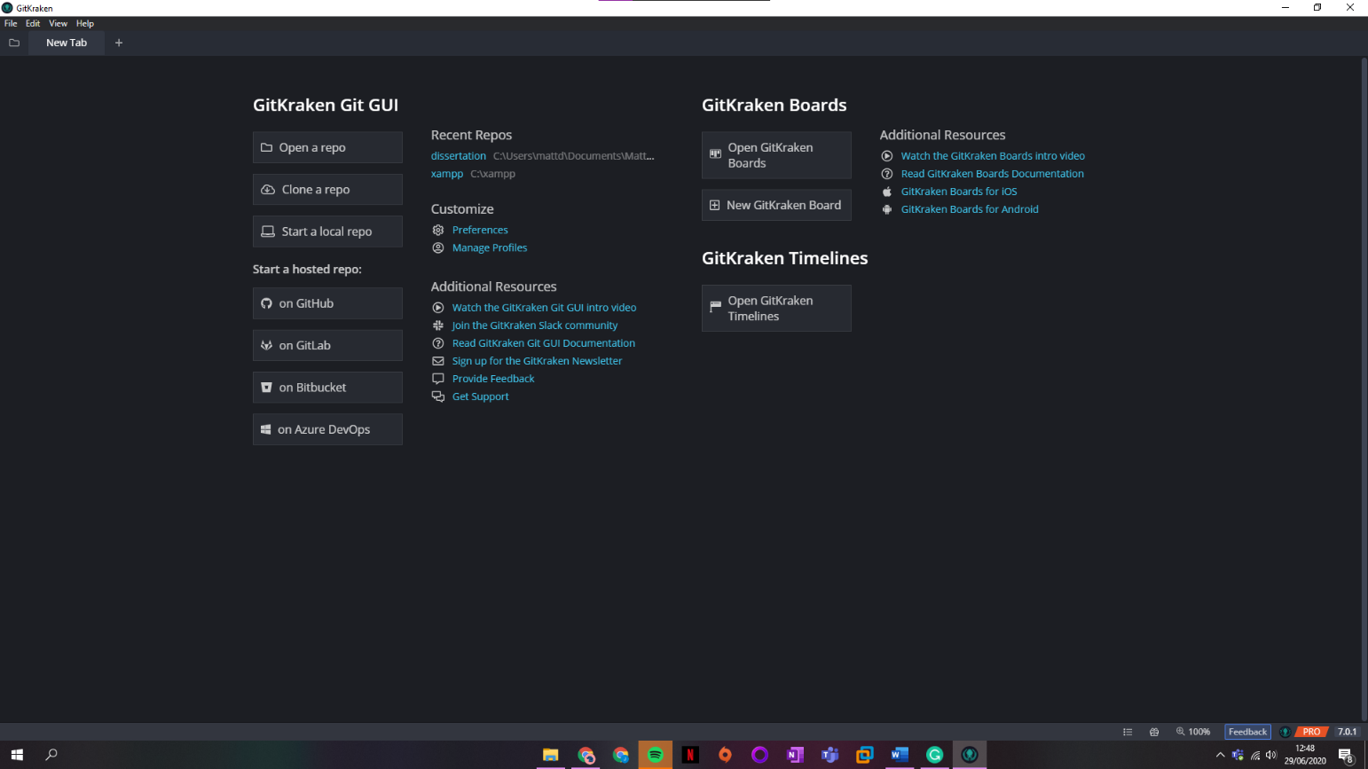

# Step 2

Click on the highlighted button under the **Start a hosted Repo** heading. The button is titled **on GitHub** with the GitHub Logo to the left.

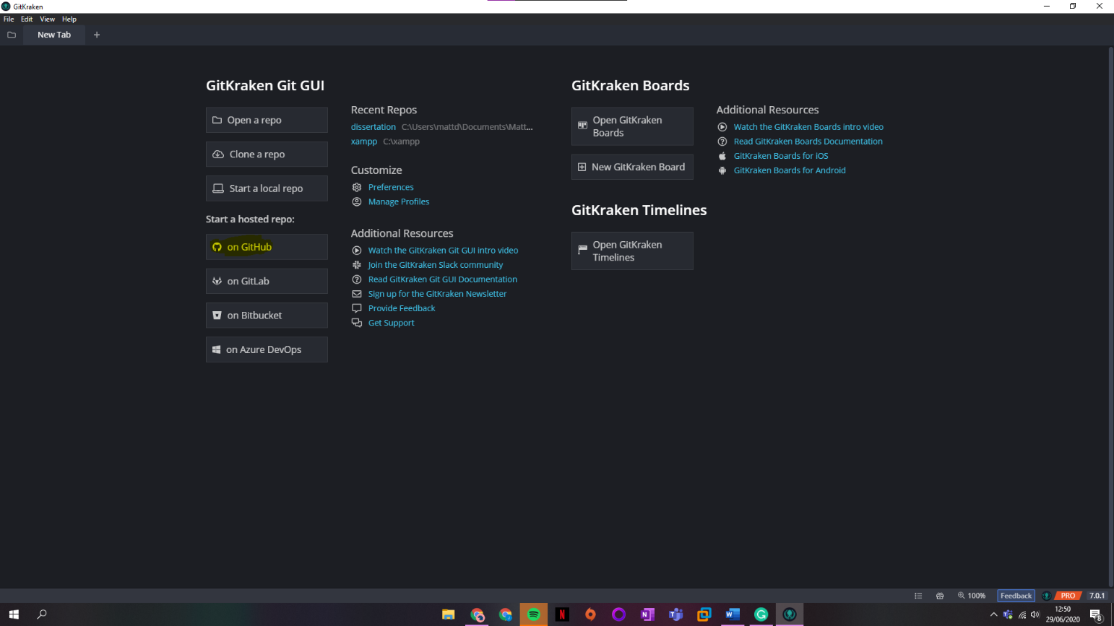

# Step 3

A window titled **Repository Management** will pop-up. As one can see, we have options such as **Open, Clone** and **Init.** In the central column, we can see that Github.com was pre-selected for us. To the right, we can see various fields required to create a new repo on the Github service.

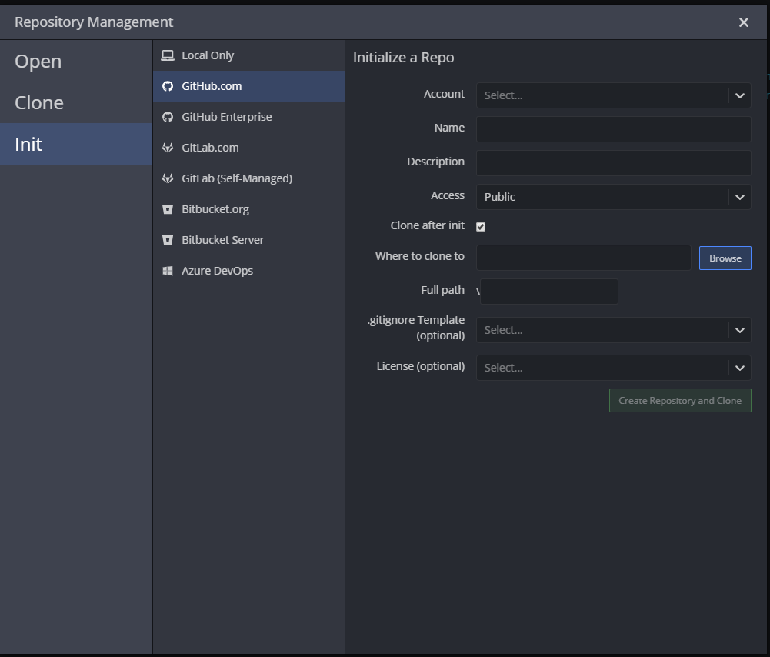

# Step 4

Fill in the details and click the **Create Repository** button.

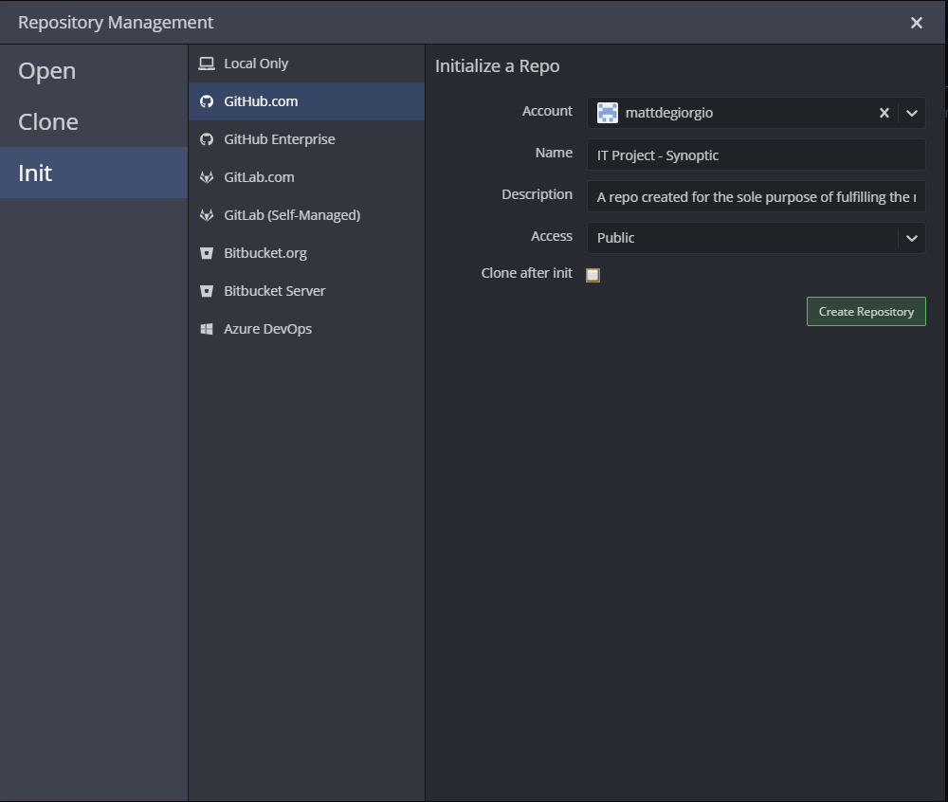

# Step 5

Upon Creation, a pop-up will appear on the left corner of the interface. One can click the link to view repo online on a Github.

